
Capital Needs Assessment Survey Results
December 2019

Jesse White
Secretary of State

Public Act 96-0037, the Public Library Construction Act, requires the Illinois Secretary of State to file a comprehensive assessment report of the capital needs of all Illinois public libraries to the General Assembly every two years. To compile this assessment needs report, the Illinois State Library included the Capital Needs Assessment Survey in the Illinois Public Library Annual Report survey which is a required submission by all Illinois public libraries. Information was also gathered from 102 Illinois county clerks to compile the data on Equalized Assessed Valuation trends.
Overview
Responses were submitted by 641 public libraries that reported $527 million of capital needs for general repair work, building additions and new building construction for the next two years. Significant findings of the survey along with the data from the county clerks include:

- $200.2 million is needed for the construction of 24 new buildings.

- $76.1 million is needed for 50 building additions.

- $123.3 million is needed for general repair and remodeling for 330 library buildings.

- $28.5 million is needed by 196 library buildings for heating, ventilation, and air conditioning repairs and upgrades.
- $20.5 million is needed in 152 library buildings for roof repair or replacement.
- $19.9 million is needed by 118 libraries for structural repairs.
- $15 million in sidewalk, curbing, and parking area repairs are needed by 196 library buildings.
- $12.4 million is needed by 246 library buildings for technology upgrades.
- $7.7 million is needed to address accessibility in 92 library buildings.
- Fourteen libraries are in the process of constructing new library buildings at an estimated cost of $158.8 million.
- Nine libraries are currently enlarging their existing buildings at an estimated cost of $37.2 million.
- 135 library buildings are 100+ years old, while 187 library buildings are between 51 and 100 years old.
- From 2011 to 2017, libraries experienced a 21% decline in the Equalized Assessed Value (EAV) of the non-farm property of their library service areas.

Illinois State Library Capital Needs Assessment Survey

Type of Work Needed |  | Headquarters |  | Other Facilities |  | Library Total
General Repair/Remodeling/Renovation: |  | # of Bldgs | Estimate $ | # of Bldgs | Estimate $ | # of Bldgs | Estimate $
1 | General repair/remodeling | 280 | 101,084,461 | 50 | 22,300,900 | 330 | 123,385,361
2 | Structural repairs (walls, foundations, etc.) | 106 | 19,792,703 | 12 | 135,000 | 118 | 19,927,703
3 | Roof repairs or replacements | 134 | 19,429,338 | 18 | 1,079,600 | 152 | 20,508,938
4 | Heating/ventilation/air conditioning | 177 | 28,226,153 | 19 | 294,400 | 196 | 28,520,553
5 | Electrical systems other than alarms | 87 | 5,516,696 | 4 | 108,700 | 91 | 5,625,396
6 | Plumbing systems | 112 | 3,968,071 | 7 | 83,100 | 119 | 4,051,171
7 | Egress systems (doors, stairs, etc.) | 99 | 3,082,674 | 10 | 72,667 | 109 | 3,155,341
8 | Fire protection (detectors, alarms, etc.) | 82 | 2,991,051 | 2 | 25,200 | 84 | 3,016,251
9 | Asbestos abatement | 13 | 540,304 | 1 | 113,400 | 14 | 653,704
10 | Security measures | 138 | 2,534,223 | 13 | 117,500 | 151 | 2,651,723
11 | Energy conservation | 98 | 3,799,415 | 6 | 200,000 | 104 | 3,999,415
12 | Repair of sidewalks, curbing, parking areas | 172 | 13,956,948 | 24 | 1,131,800 | 196 | 15,088,748
13 | Accessibility measures | 88 | 7,654,218 | 4 | 56,000 | 92 | 7,710,218
14 | Technological upgrading | 219 | 11,653,396 | 27 | 778,000 | 246 | 12,431,396
 | Subtotal General Repair/Remodeling/Renovation |  | 224,229,651 |  | 26,496,267 |  | 250,725,918
New building construction (construction of a new facility) |  | 21 | 139,705,002 | 3 | 60,500,000 | 24 | 200,205,002
Building additions (adding square feet to existing facility) |  | 46 | 73,360,000 | 4 | 2,770,000 | 50 | 76,130,000
 | Total Work Needed |  | 437,294,653 |  | 89,766,267 |  | 527,060,920

Type of Work in Progress |  | Headquarters |  | Other Facilities |  | Library Total
General Repair/Remodeling/Renovation: |  | # of Bldgs | Estimate $ | # of Bldgs | Estimate $ | # of Bldgs | Estimate $
1 | General repair/remodeling | 111 | 36,814,021 | 11 | 18,488,604 | 122 | 55,302,625
2 | Structural repairs (walls, foundations, etc.) | 29 | 1,948,910 | 0 | 0 | 29 | 1,948,910
3 | Roof repairs or replacements | 41 | 3,039,619 | 1 | 500 | 42 | 3,040,119
4 | Heating/ventilation/air conditioning | 70 | 5,817,730 | 6 | 94,240 | 76 | 5,911,970
5 | Electrical systems other than alarms | 30 | 1,989,006 | 1 | 15,000 | 33 | 2,004,006
6 | Plumbing systems | 33 | 626,215 | 2 | 13,000 | 35 | 639,215
7 | Egress systems (doors, stairs, etc.) | 22 | 313,552 | 2 | 4,667 | 24 | 318,219
8 | Fire protection (detectors, alarms, etc.) | 18 | 447,890 | 2 | 400 | 20 | 448,290
9 | Asbestos abatement | 1 | 5,000 | 1 | 25,000 | 2 | 30,000
10 | Security measures | 38 | 849,974 | 2 | 25,000 | 40 | 874,974
11 | Energy conservation | 25 | 666,816 | 0 | 0 | 25 | 666,816
12 | Repair of sidewalks, curbing, parking areas | 38 | 1,425,299 | 4 | 165,000 | 42 | 1,590,299
13 | Accessibility measures | 11 | 378,887 | 1 | 500 | 12 | 379,387
14 | Technological upgrading | 89 | 2,427,668 | 7 | 264,000 | 96 | 2,691,668
 | Subtotal General Repair/Remodeling/Renovation |  | 56,750,587 |  | 19,095,911 |  | 75,846,498
New building construction (construction of a new facility) |  | 7 | 113,994,768 | 7 | 44,801,000 | 14 | 158,795,768
Building additions (adding square feet to existing facility) |  | 7 | 21,650,857 | 2 | 15,600,000 | 9 | 37,250,857
 | Total Work in Progress |  | 192,396,212 |  | 79,496,911 |  | 271,893,123

Equalized Assessed Valuation (EAV) Trends | 2011 | 2012 | 2013 | 2014 | 2015 | 2016 | 2017 | Decline over  7-year period
Total EAV (in billions) | $337 | $325 | $301 | $283 | $268 | $269 | $266 | $-71

Work Needed

Currently, a need of $527 million is estimated for general repairs, building additions and new building construction. The chart below summarizes the needs of the 641 survey respondents.

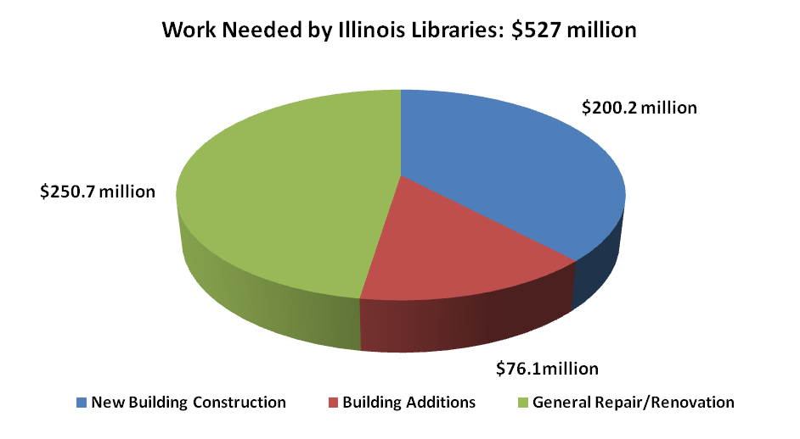

General Renovation and Repair

The estimated need for $250.7 million of general renovation and repair work is represented in the bar chart below. These needs are projected within the next two years, and are over and above the work in progress through 2019.

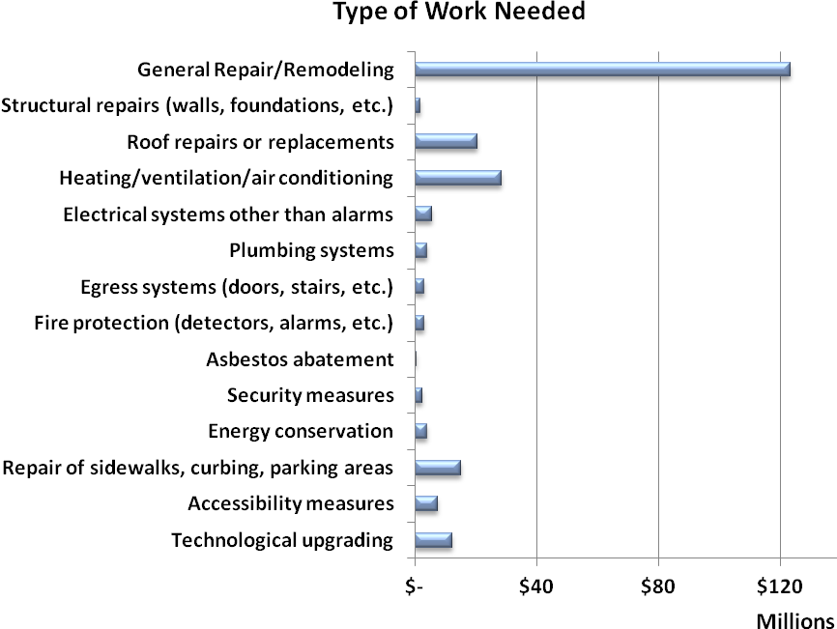

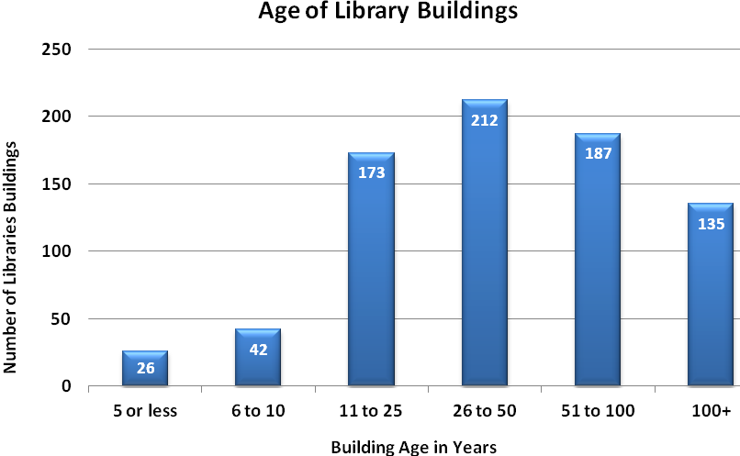

Equalized Assessed Value Trends

Data collected from Illinois county clerks to calculate the annual Public Library Per Capita and Equalization Aid Grant award highlights a sharp five-year statewide decline, a short one-year stabilization, followed by another decline in the value of taxable non-farm property in library service areas.

