**Section 905.APPENDIX A Illustrations and Exhibits**

**Section 905.ILLUSTRATION J Septic Tank Subsurface Seepage Field**

**Section 905.EXHIBIT A Plan View – Gravel System**



(Source: Amended at 27 Ill. Reg. 2431, effective March 15, 1996)

**Section 905.APPENDIX A Illustrations and Exhibits**

**Section 905.ILLUSTRATION J Septic Tank Subsurface Seepage Field**

**Section 905.EXHIBIT B Section View – Gravel System**



(Source: Amended at 27 Ill. Reg. 2431, effective March 15, 1996)

**Section 905.APPENDIX A Illustrations and Exhibits**

**Section 905.ILLUSTRATION J Septic Tank Subsurface Seepage Field**

**Section 905.EXHIBIT C Plan View – Gravelless and Chamber System**

**Building sewer**

**Septic tank**

**Point of entry to seepage field**

**100 feet maximum from point of entry.**

**7 to 9 Feet minimum separation distance see Appendix A, Illustration I, Exhibit D**

**Plan view**

**5 feet**

**Building drain**

**Building foundation**

**Gravelless pipe or Chamber system**

(Source: Amended at 37 Ill. Reg. 14994, effective August 28, 2013)

**Section 905.APPENDIX A Illustrations and Exhibits**

**Section 905.ILLUSTRATION J Septic Tank Subsurface Seepage Field**

**Section 905.EXHIBIT D Section View – Gravelless and Chamber System**

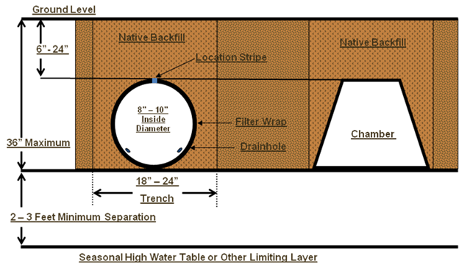

(Source: Amended at 37 Ill. Reg. 14994, effective August 28, 2013)