**Section 890.APPENDIX G Illustrations for Subpart G**

**Section 890.ILLUSTRATION B Cast Iron Soil Pipe Support #2**

(Referenced in Section 890.920)

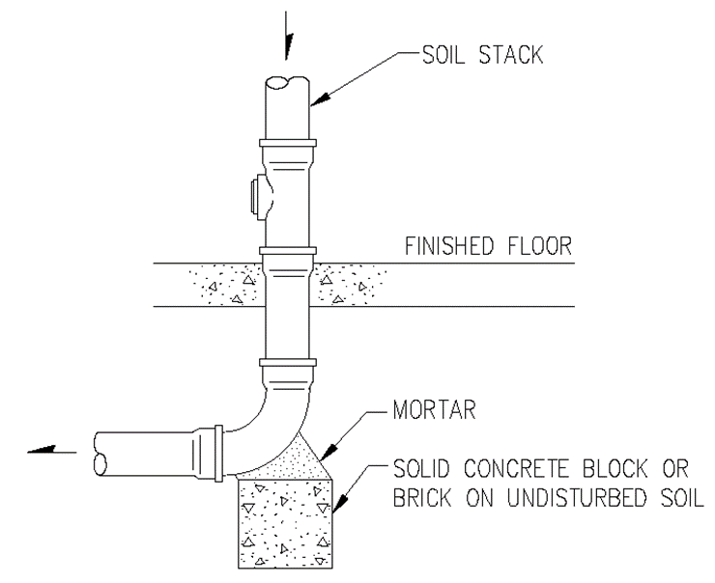

(Source: Amended at 38 Ill. Reg. 9940, effective April 24, 2014)