Section 1255.45 Seal and Signature Requirements

Every registered interior designer shall have a reproducible seal, or facsimile, the print of which shall contain the name of the registered interior designer, the registration number, and words "Registered Interior Designer, State of Illinois". The registered interior designer shall affix the signature, current date, date of registration expiration and seal to the first sheet of any bound set or loose sheets of technical submissions utilized as contract documents between the parties to the contract or contracts or prepared for the review and approval of any governmental or public authority having jurisdiction to issue a permit by that registered interior designer or under that registered interior designer's responsible control.

a) The individual registrant's written signature and date of signing, along with the date of registration expiration, shall be placed adjacent to the seal.

b) The registrant may provide, at the registrant's sole discretion, an original signature in the registrant's handwriting, a scanned copy of the document bearing an original signature, or a signature generated by a computer.

c) The following is a suggested facsimile of the design and lettering of the seal:

Sample

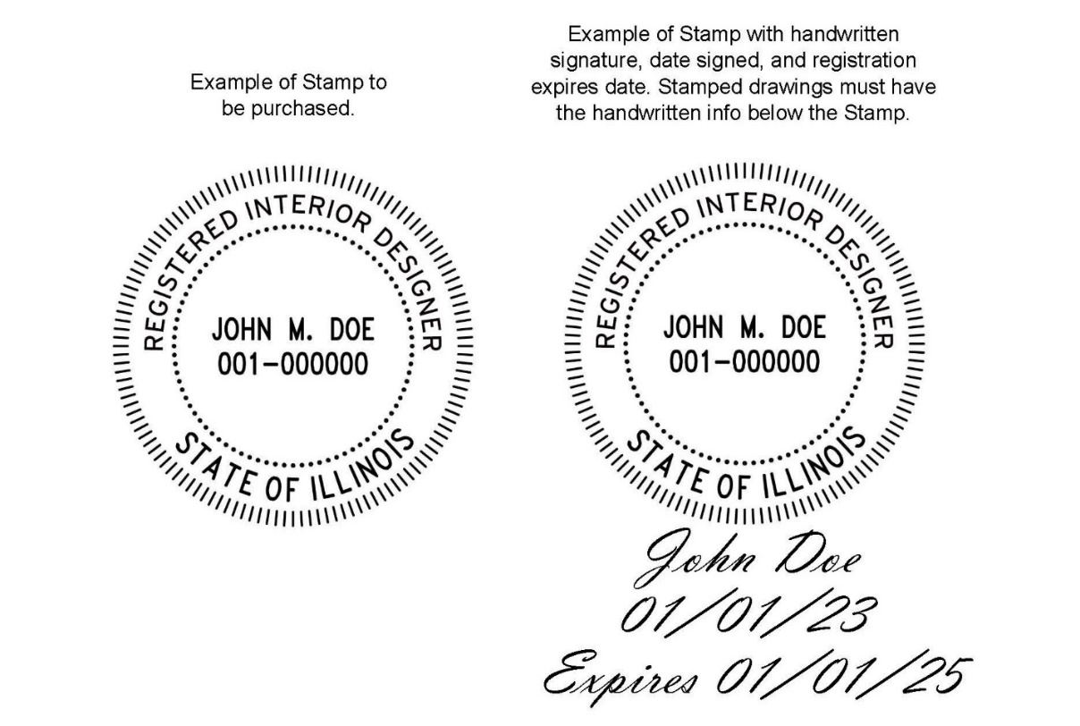

[Signature]
[Date Signed]
Registration Expires: [Date]

(Source: Amended at 48 Ill. Reg. 12276, effective August 2, 2024)

