**Section 5375.APPENDIX A Organization Chart**

ILLINOIS STUDENT ASSISTANCE COMMISSION

ORGANIZATION CHART

**COMMISSION**

EXECUTIVE DIRECTOR

MANAGING DIRECTOR, RESEARCH PLANNING AND POLICY ANALYSIS

DIRECTOR, PROGRAM SERVICES AND COMPLIANCE

MANAGING DIRECTOR, COMMUNITY SERVICES

MANAGING DIRECTOR, COLLEGE ACCESS INITIATIVES

DEPUTY EXECUTIVE DIRECTOR

CHIEF FINANCIAL OFFICER

CHIEF MARKETING AND COMMUNICATIONS OFFICER

EXECUTIVE SECRETARY

SECRETARY TO THE COMMISSION

GENERAL COUNSEL

CHIEF INVESTMENT OFFICER

DIRECTOR, INTERNAL AUDIT

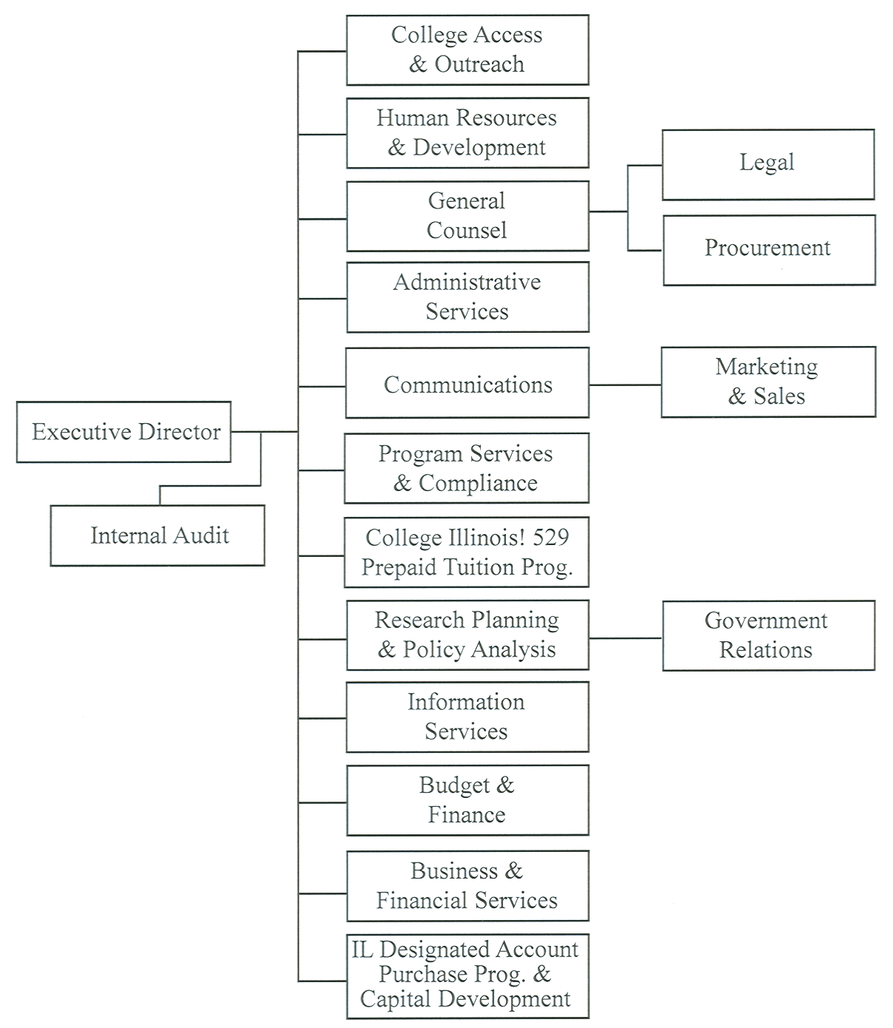

(Source: Amended at 36 Ill. Reg. 5840, effective April 1, 2012)